

VACCINATION MANAGEMENT SYSTEM

USER’S GUIDE:

Aptech North Karachi | CPISM | June 22, 2024



|  |  |  |
| --- | --- | --- |
|  |  |  |
| **Advisor/Teacher/Instructor** | SIR MUHAMMAD ADEEL | |
| **Batch Code** | 2307G1 | |
| **Serial Number** | **Enrollment Number** | **Student Name** |
| **1** | Student1486692 | DANIAL MIRZA |
| **2** | Student1486713 | UZAIR AHMED KHAN |
| **3** | Student1487240 | ABDULLAH SHAKIL |
| **4** | Student1488154 | HAROON MUZAFFAR |

# Acknowledgement

The First, we are thankful to our God (Allah S.W.T) who give us strength to solve this Challenging task and improve our skills with the help of our will power.

The Second, we would like to express our special thanks of gratitude to our respectable and honorable teacher Sir Adeel Habib, who helped us and trained us a lot in finalizing this project within the given time frame, valuable counselling and assistance for the accomplishment of this Project.

After all, we are especially thankful to the Aptech eProject team, who give us immense pleasure to address us about eProject. They provide us a new way of learning, which would value add the existing course material that has been provided to us.

# eProject Synopsis

The Vaccination Management System website is designed for the Parents for getting their child vaccinated in a smart way without any hassle. The website includes the list of vaccines along with vaccine details, B It also includes the list of top rated hospitals from where you can book appointments online directly.

# REQUIREMENTS OF THE PROJECT WHICH ASSIGNED US FROM APTECH

# **Vaccination Management System**

# Introduction:

In the existing system, Vaccines are provided for infants and children under teenage by various aspects such as by attending school manually and there is a chance that some of the children’s and infants may miss the opportunity of getting vaccinated due to some mandatory reasons. Which leads to loss of life or gets affected by various diseases such as polio… etc? This is a time delay process to wait for each and every one all over the places.

# Proposed Solution:

We can change this manual system into e-vaccination system by collecting the info of infants, registered under website so that those who didn’t took vaccination can avail one more opportunity to save the life of their children . By this system a lot of man-hours can be saved and it is efficient too.

# System Modules:

## **Admin**

* All child details
* Date & time of vaccination
* Report of vaccination
  + Child, Vaccination (Date wise report)
* List of vaccine
  + available or unavailable
* Request from parents
  + Approve or Reject
* Add Hospital
  + Update/Delete Hospital
* List of hospitals
* Booking Details

## **Parent**

* Register & Login
* Details of child
* Vaccination Dates
* Book Hospital
* Request for hospital
* Report of vaccination taken
* My profile

## **Hospital**

* Register & Login
* Update Vaccine status

# Modules Description

## **Admin**

* All child details
  + View all child profile details
* Date of vaccination
  + Upcoming Date of vaccination of all child
* Report of vaccination
  + Child, Vaccination (Date wise report)
* List of vaccine
  + available or unavailable
  + Admin can view the availability of the vaccination
* Request from parents
  + Approve or Reject
  + Once the request for appointment from parent side, it will be approved from the admin
* Add Hospital
  + Admin can add the hospital details
* Update/Delete Hospital
  + Admin can update or delete the hospital details
* List of hospitals
  + Admin can view the hospital details
* Booking Details
  + Admin can view the booking details from parent side for booking vaccination

## **Parent**

* Details of child
  + Update and maintain the child details of vaccination
* Vaccination Dates
  + Can get notified through in Dashboard of their respective accounts about upcoming vaccinations.
* Book Hospital
  + Use can search the list of hospital and book schedule for the vaccine dates
* Report of vaccination taken
  + Can get the report status of previous vaccination of their respective Infants

## **Hospital**

* Register & Login
  + Can register and login into the app with hospital name, address and location details.
* Update Vaccine status
  + Hospital will receive the appointment once its booked from admin side. If vaccination is completed they will update the status to Vaccinated or not.

# 

# Page Details Step by Step

* Home
* About Us
* Hospitals
* Vaccines
* Appointments
* Contact
* SIGN UP & SIGN IN

# DEVELOPER’S GUIDE

When user starts the website, the below page will show on the screen

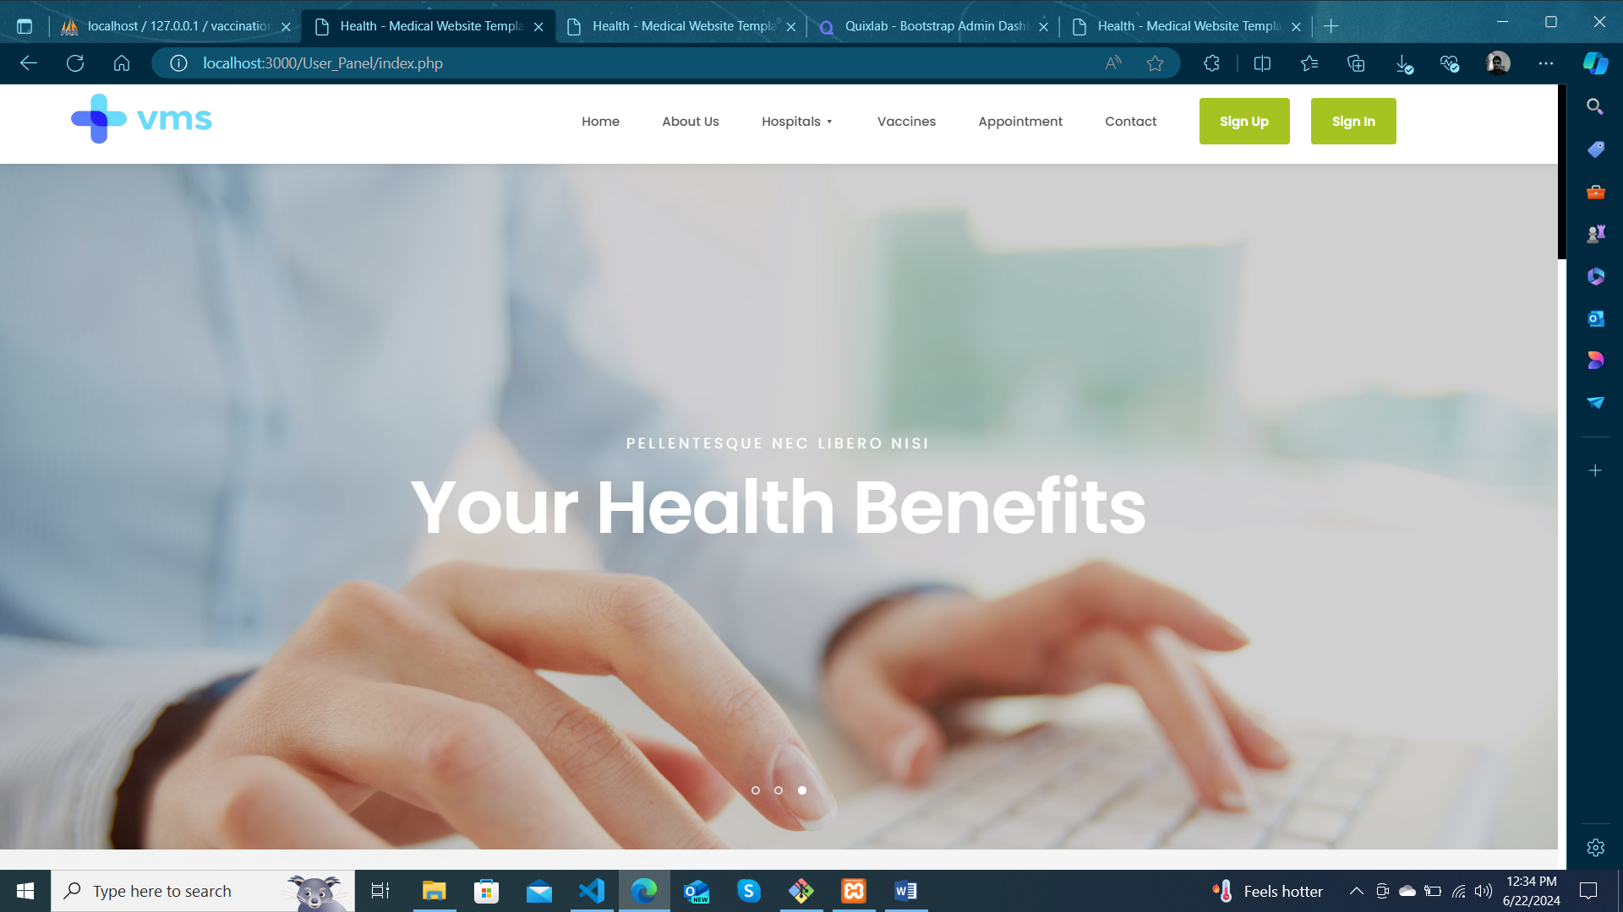

When home.html page opens then user can go to multiple pages through the Navbar link.

Let suppose when the user press on about then the following page will be displayed in front of him.

ABOUT US

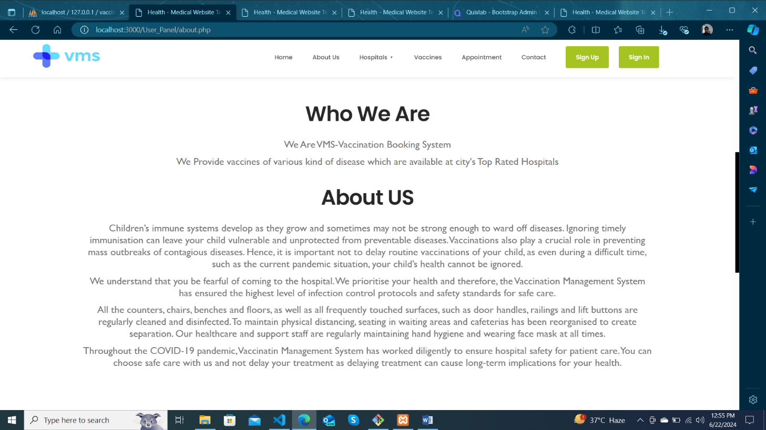

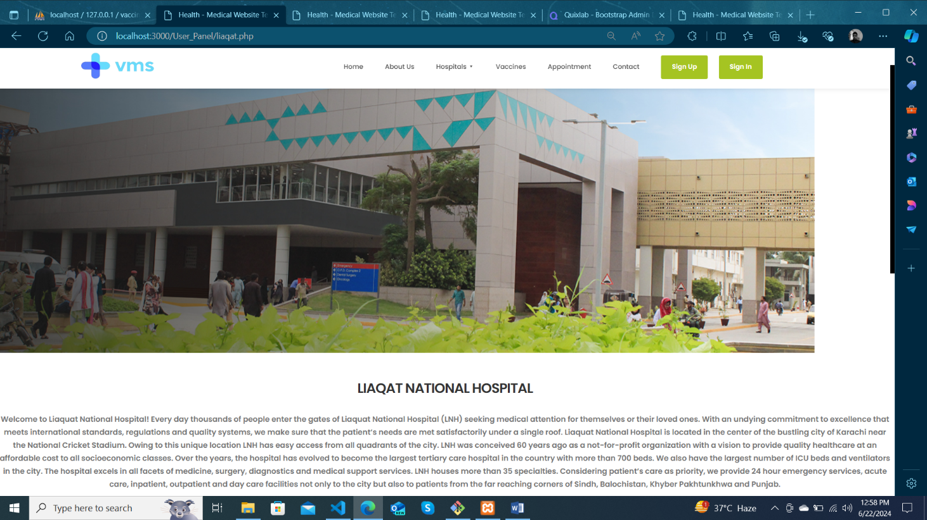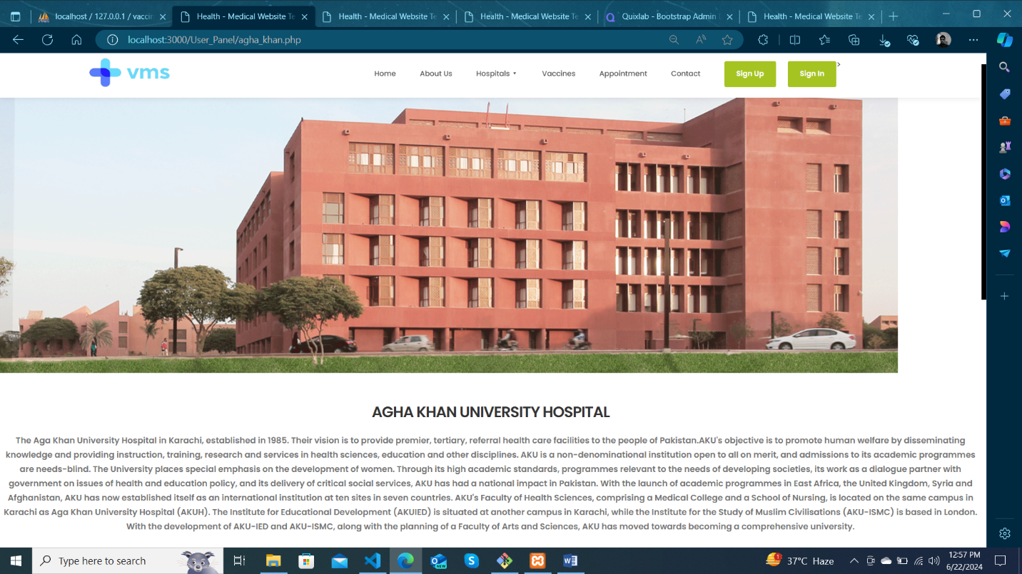HOSPITALS

HOSPITALS

(CONTINUE)

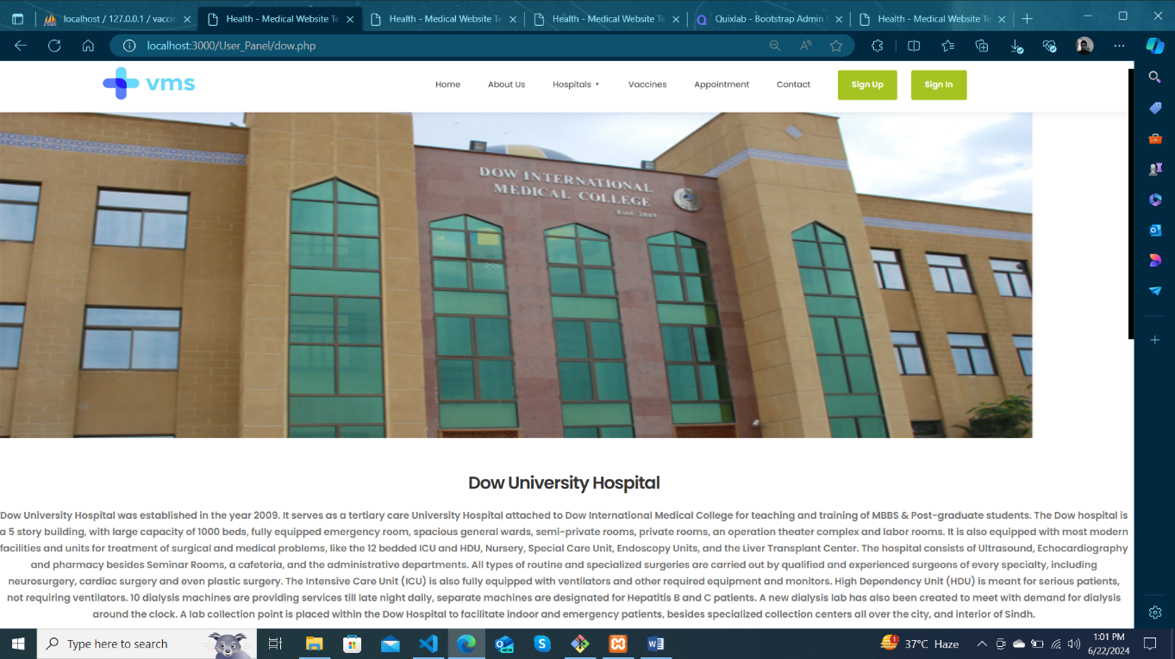

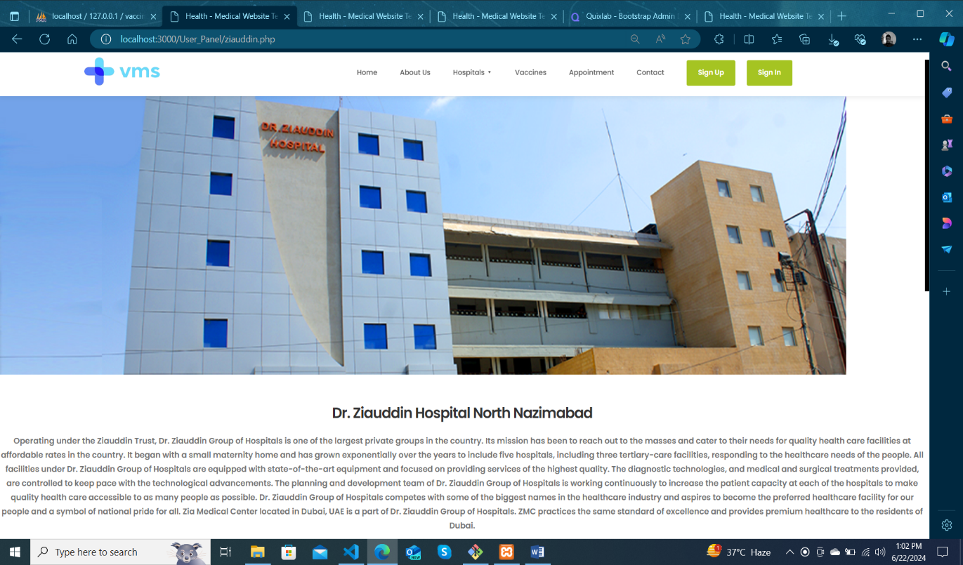

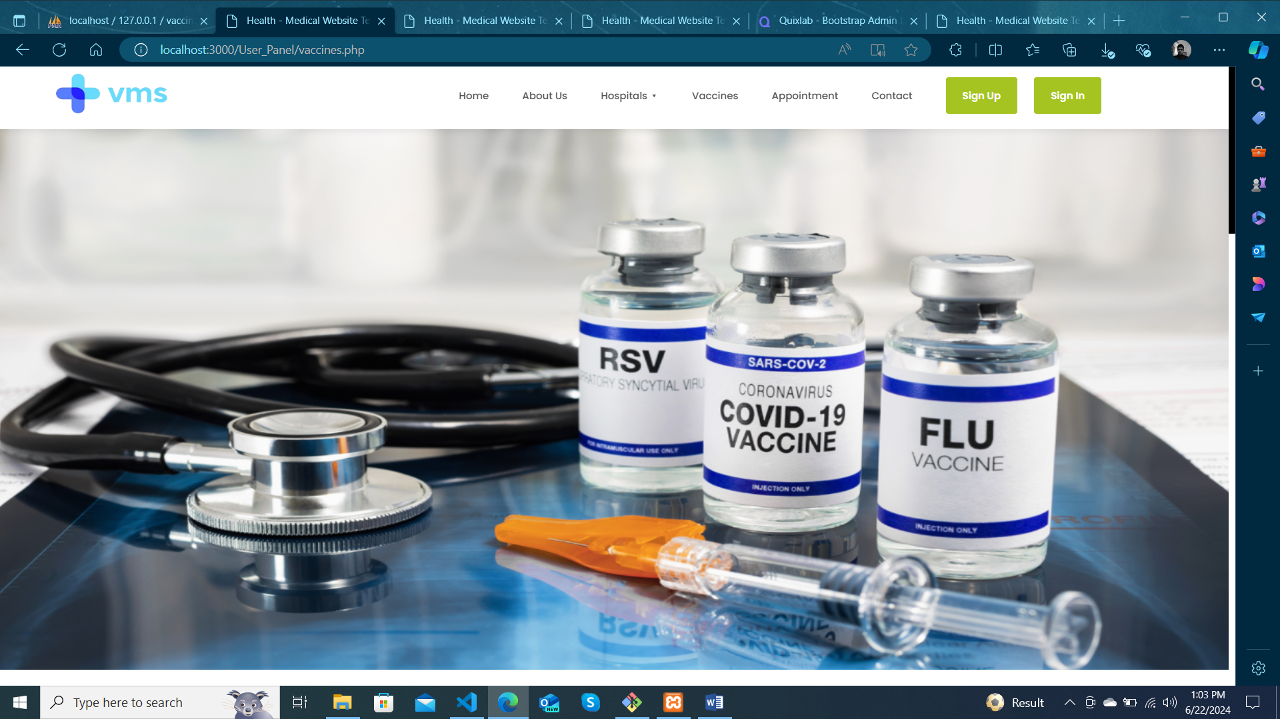VACCINES

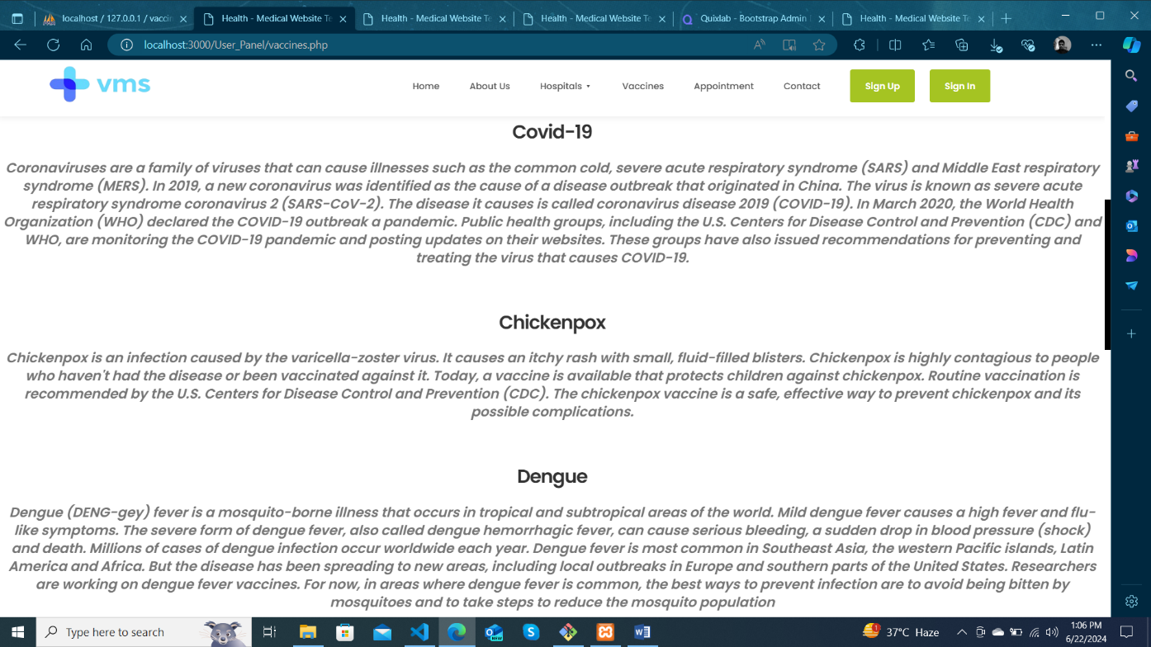

VACCINES

(CONTINUE)

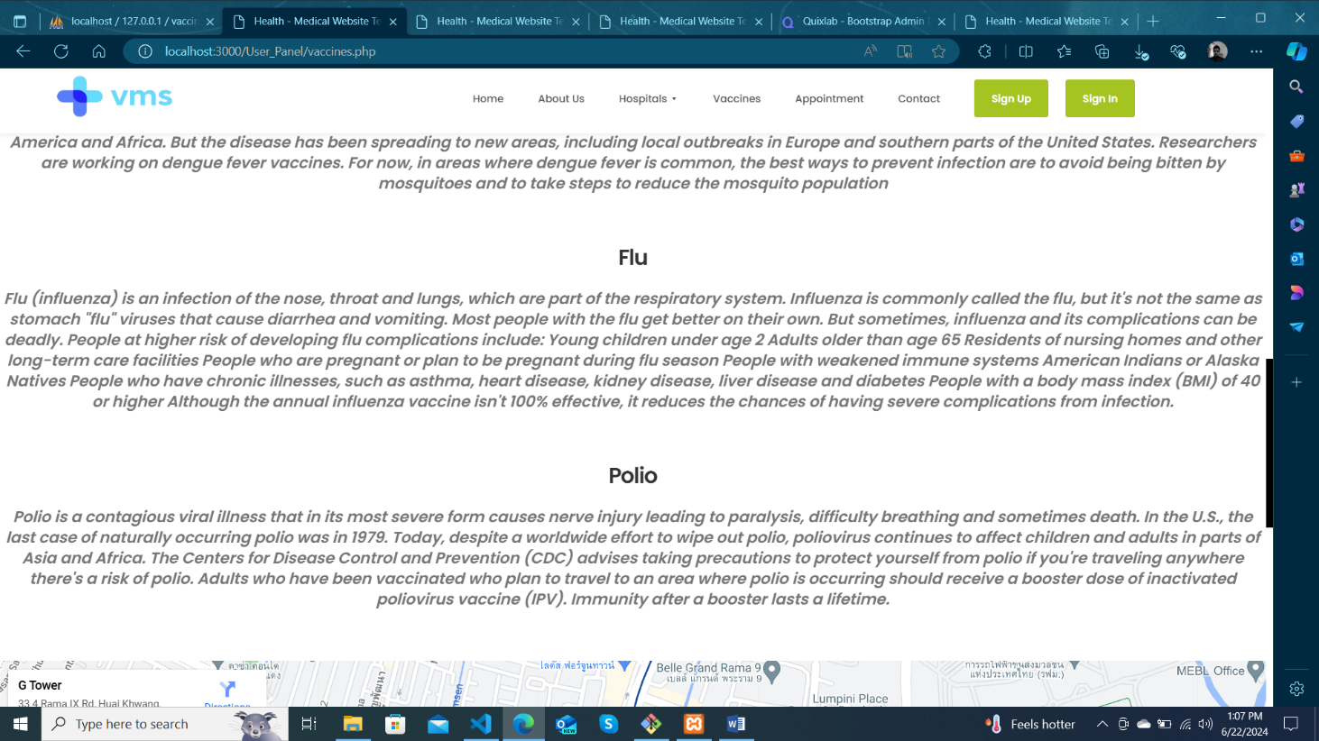

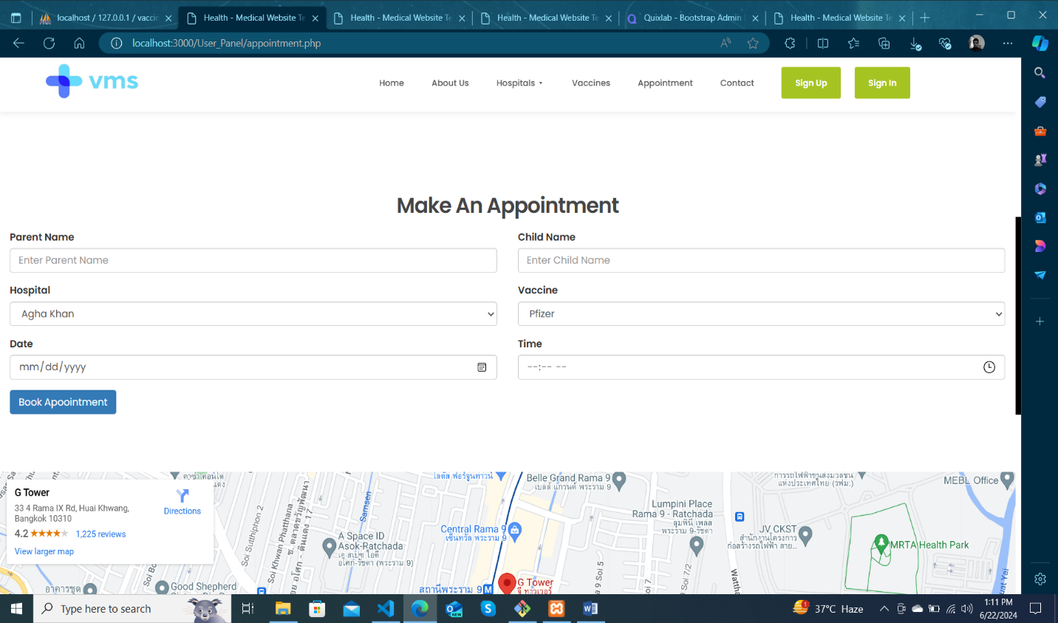APPOINTMENT

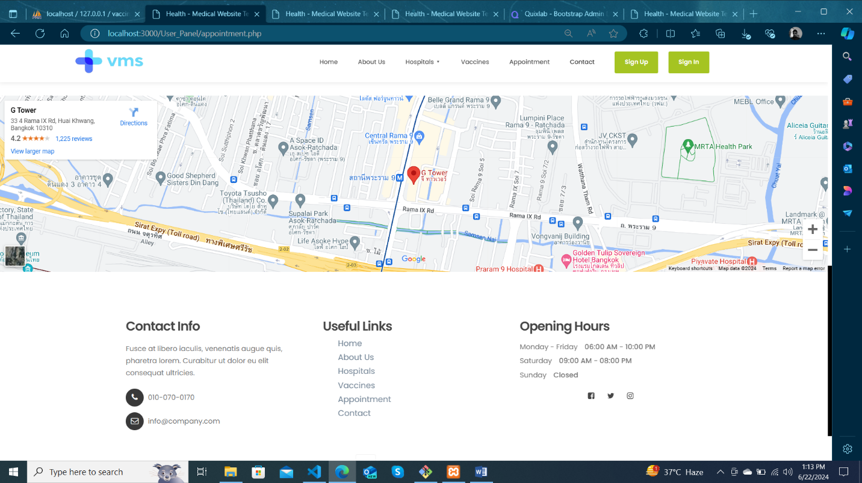CONTACT

SIGN UP & SIGN IN

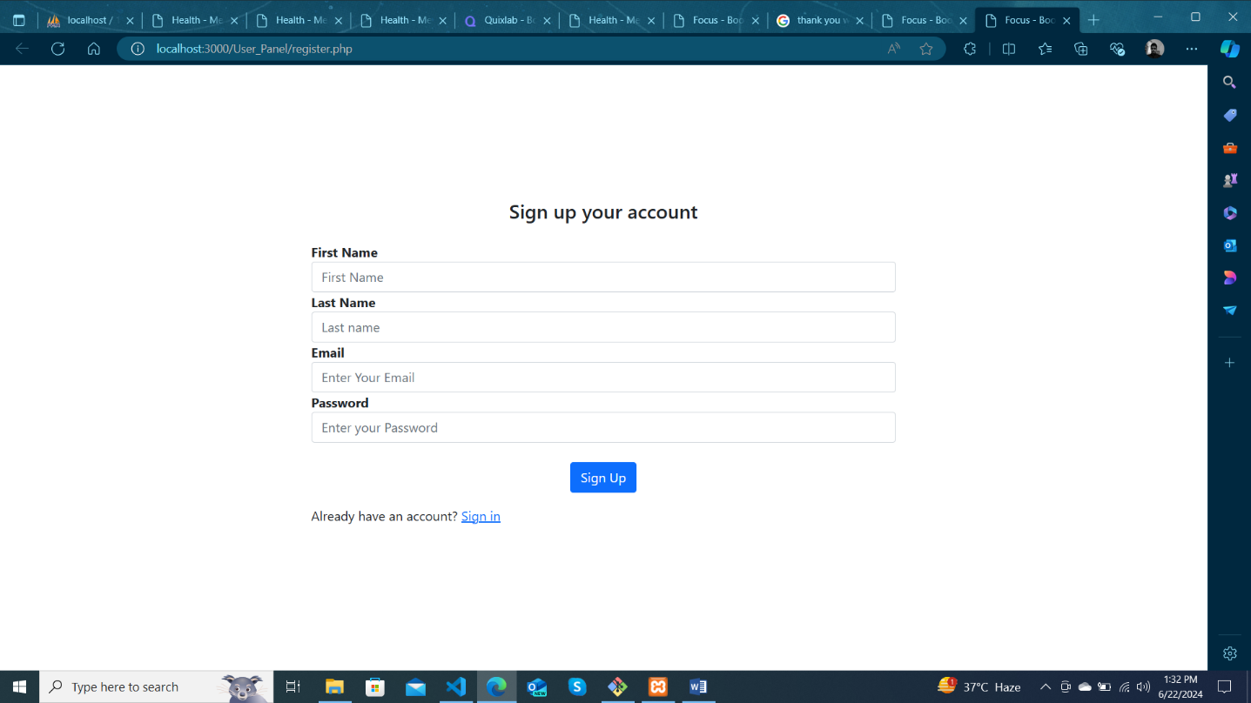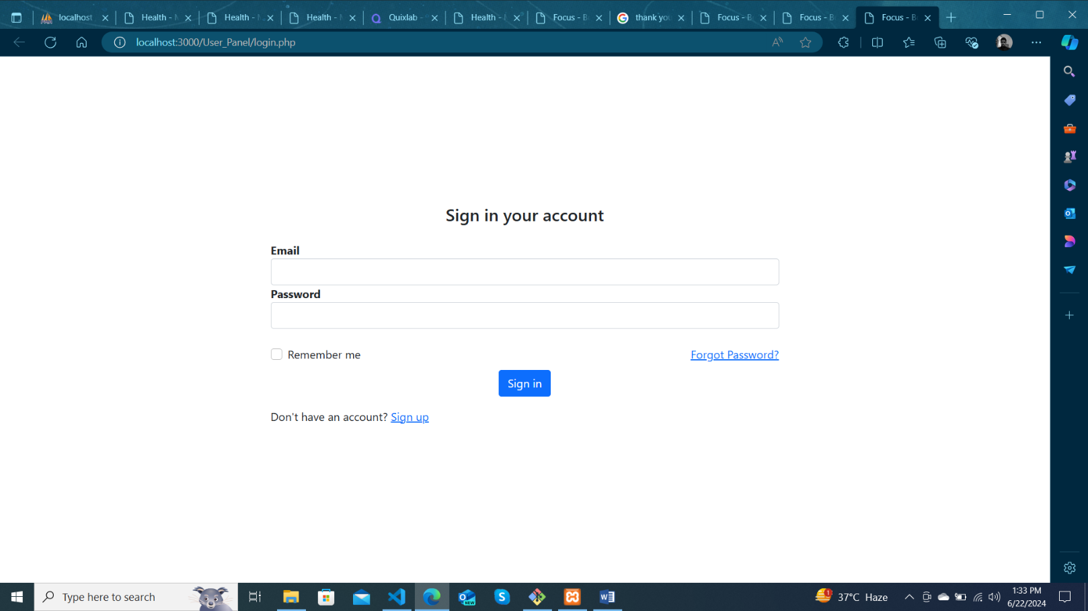

Source Code

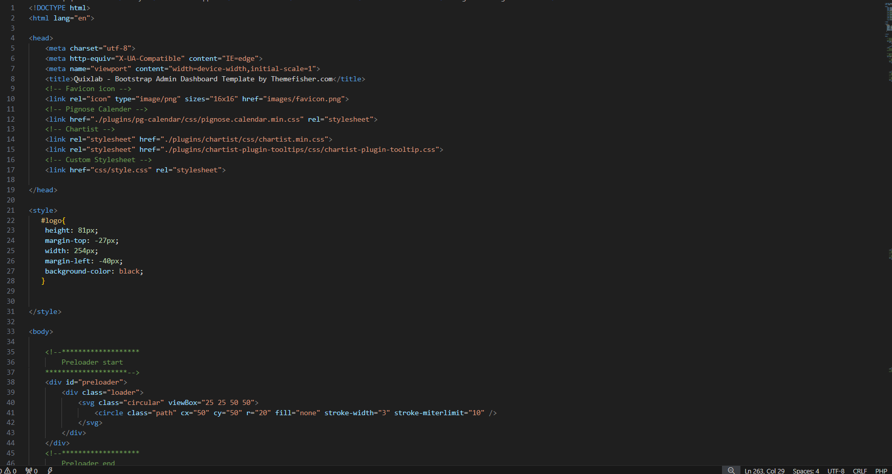

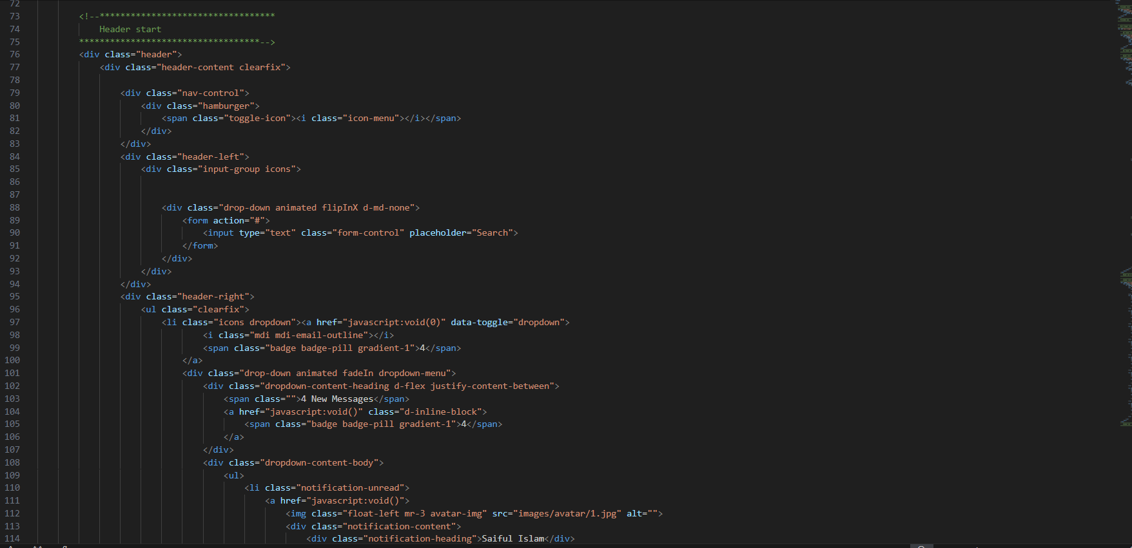

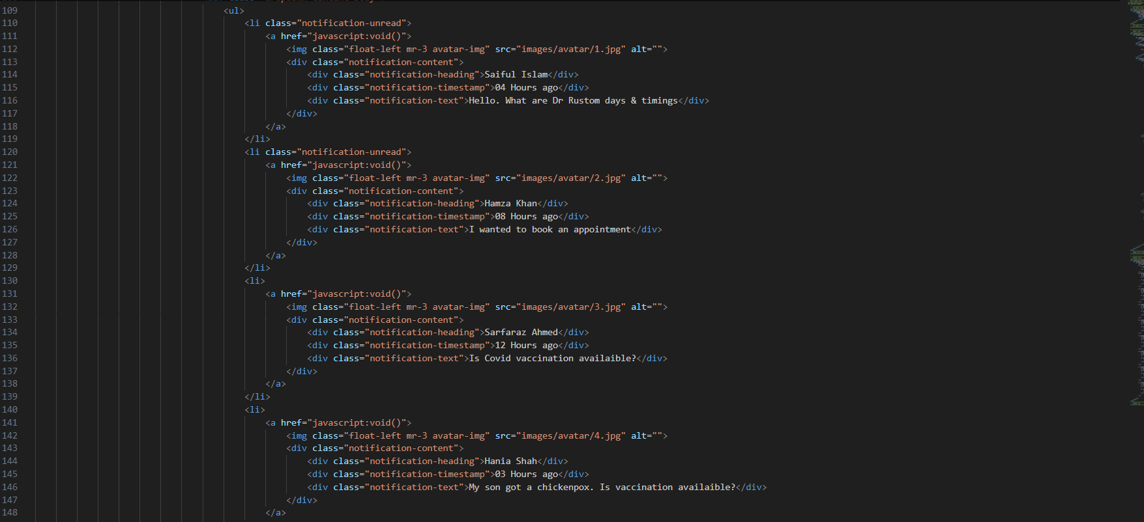

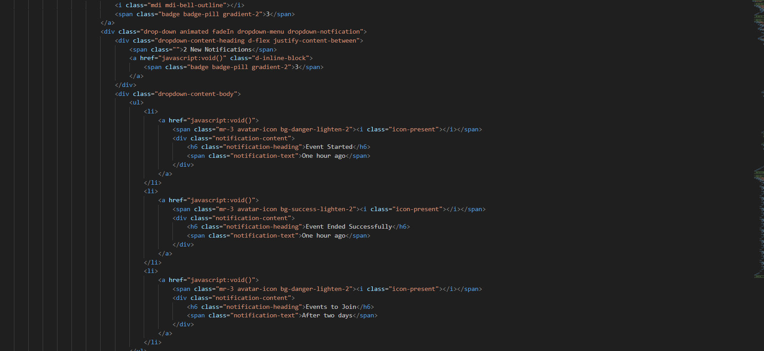

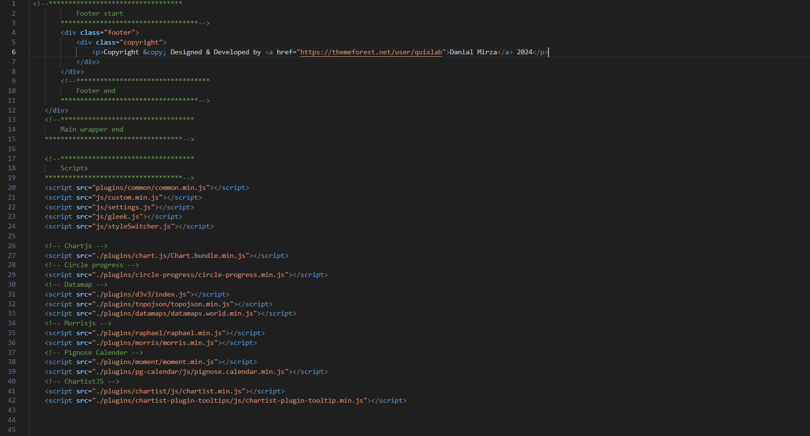

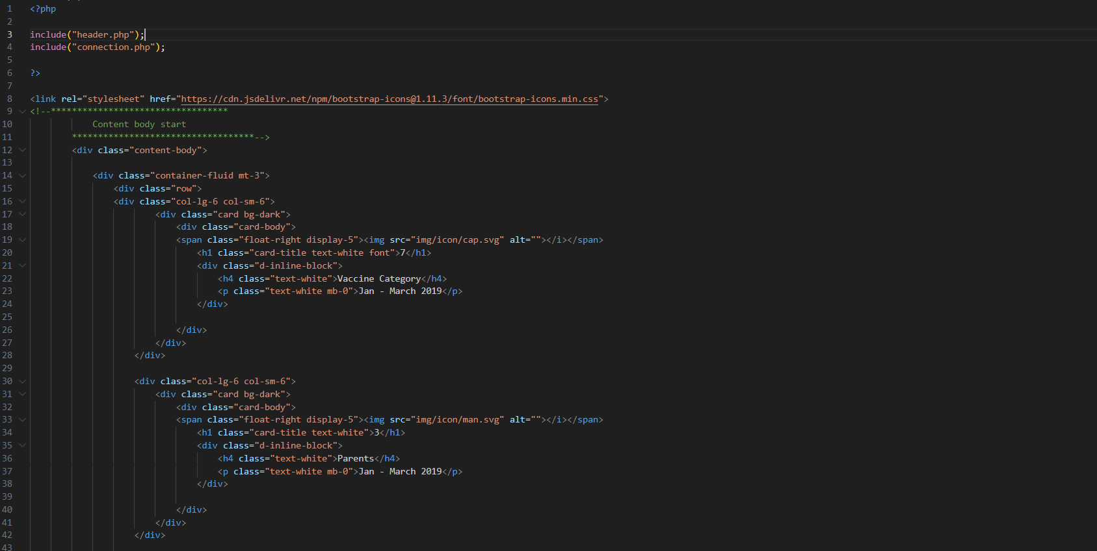

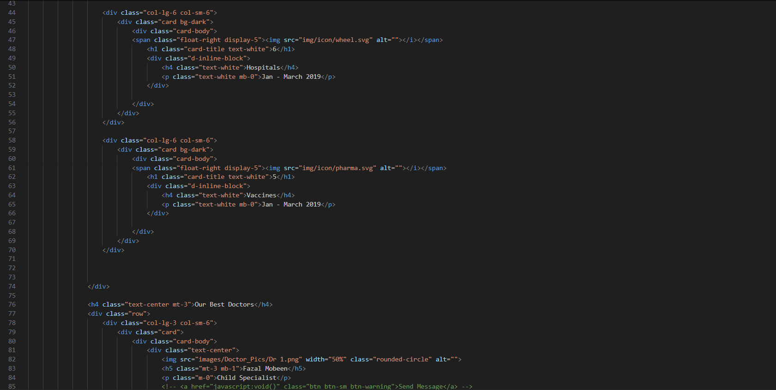

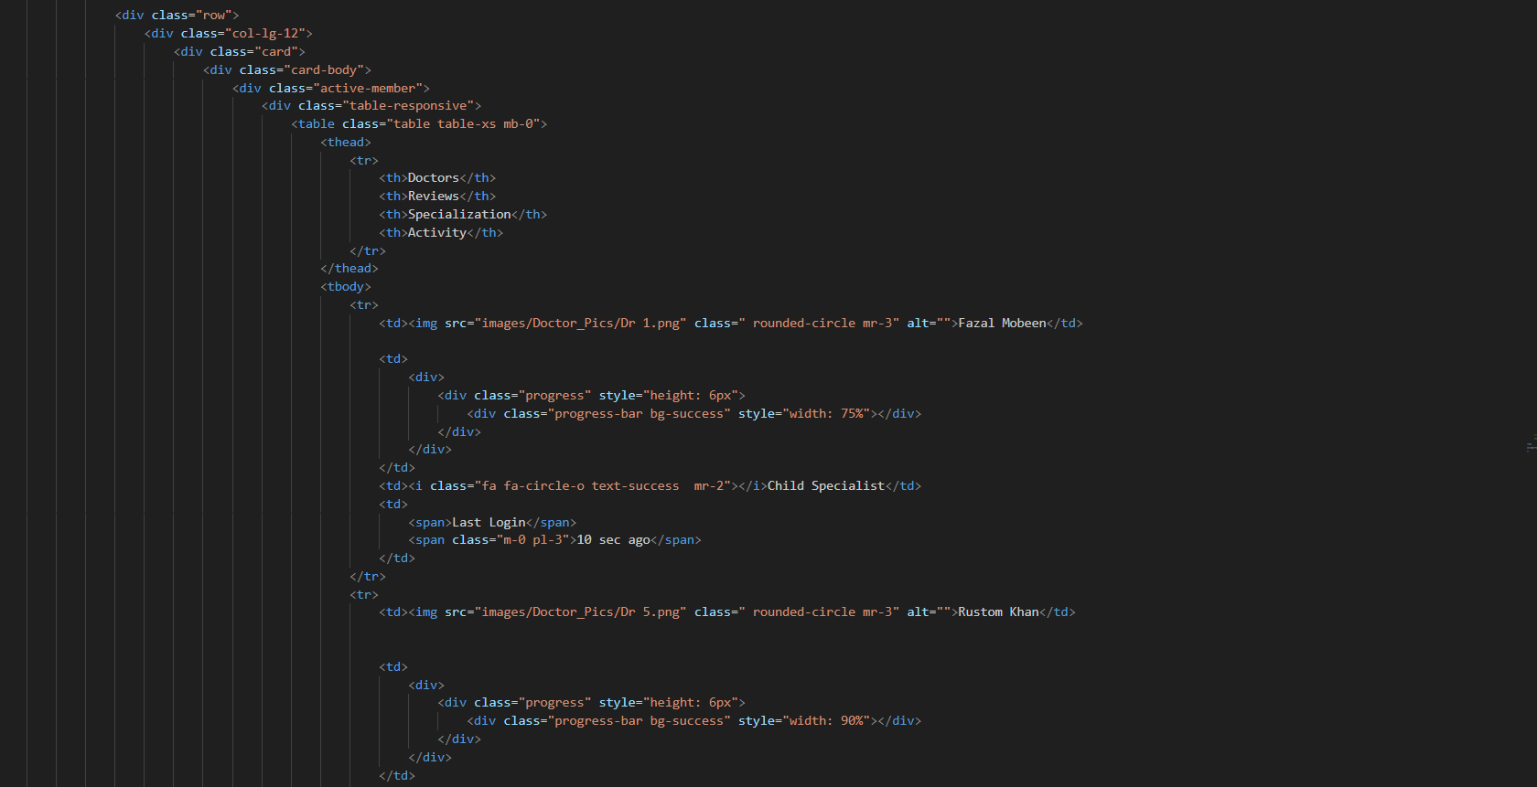

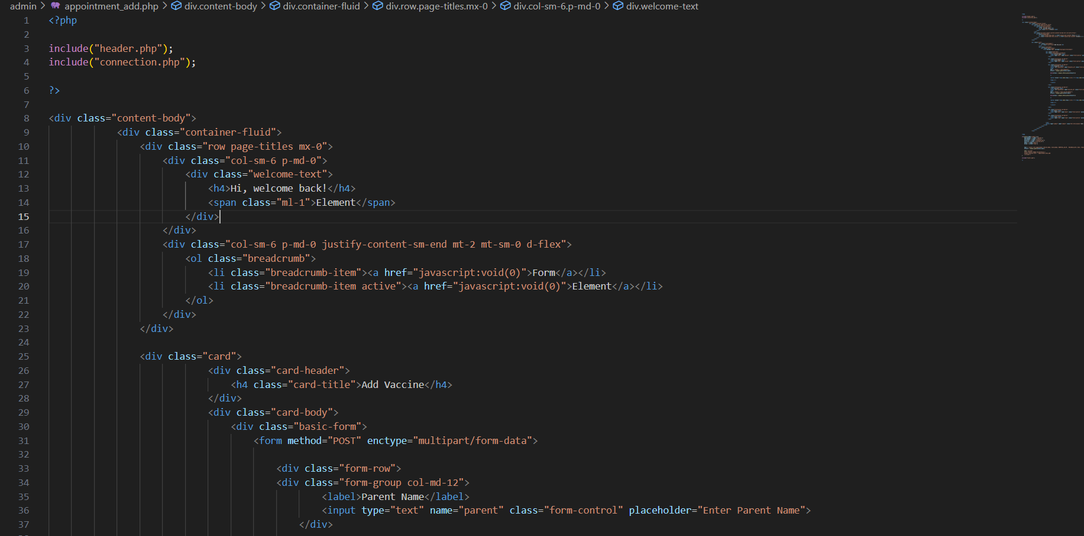

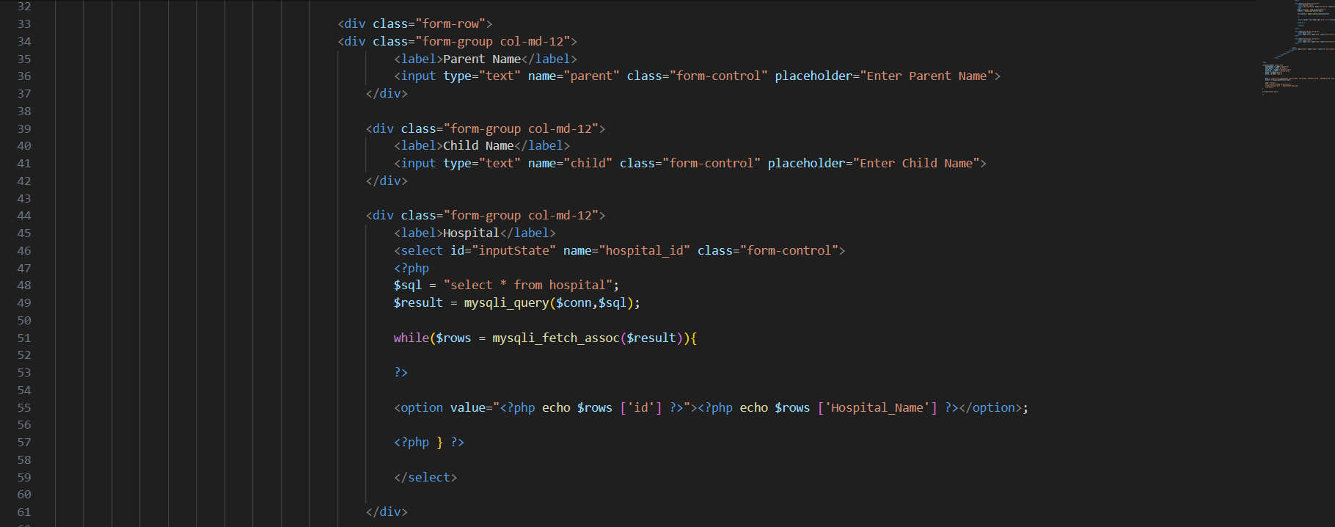

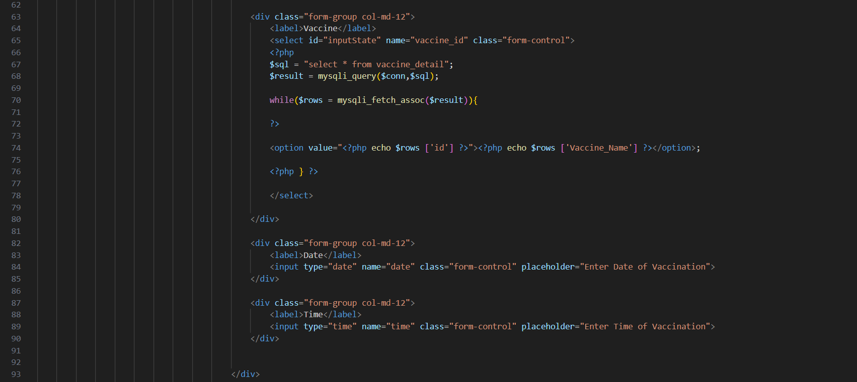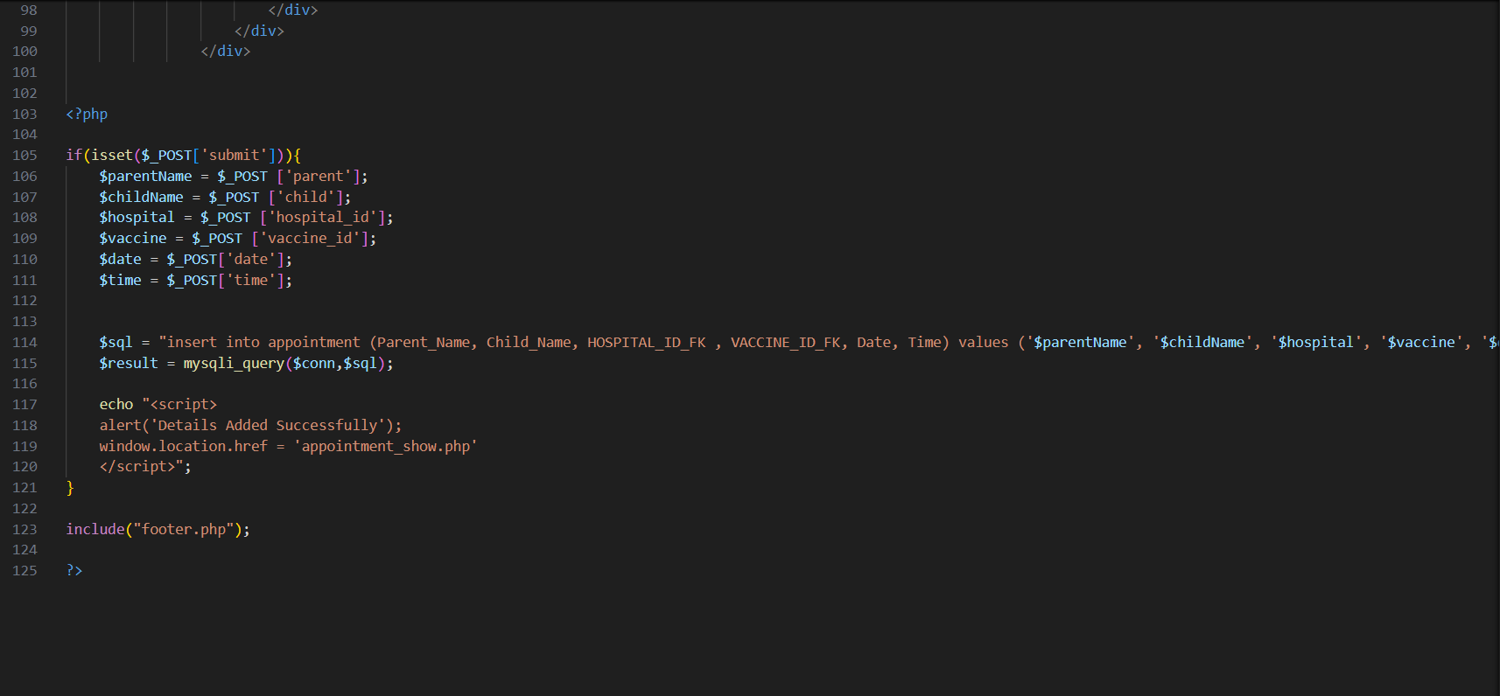

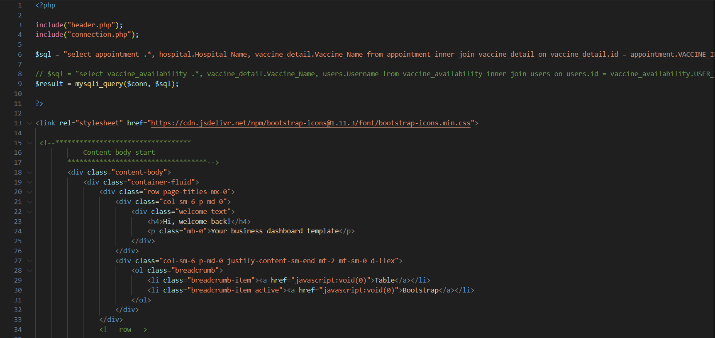

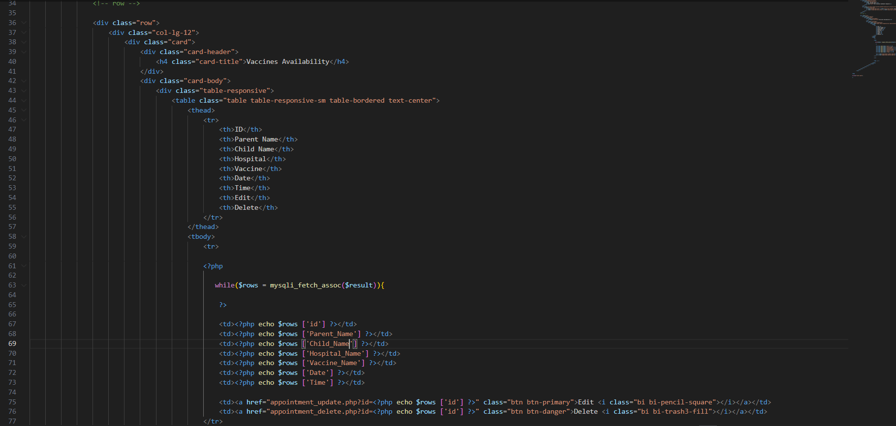

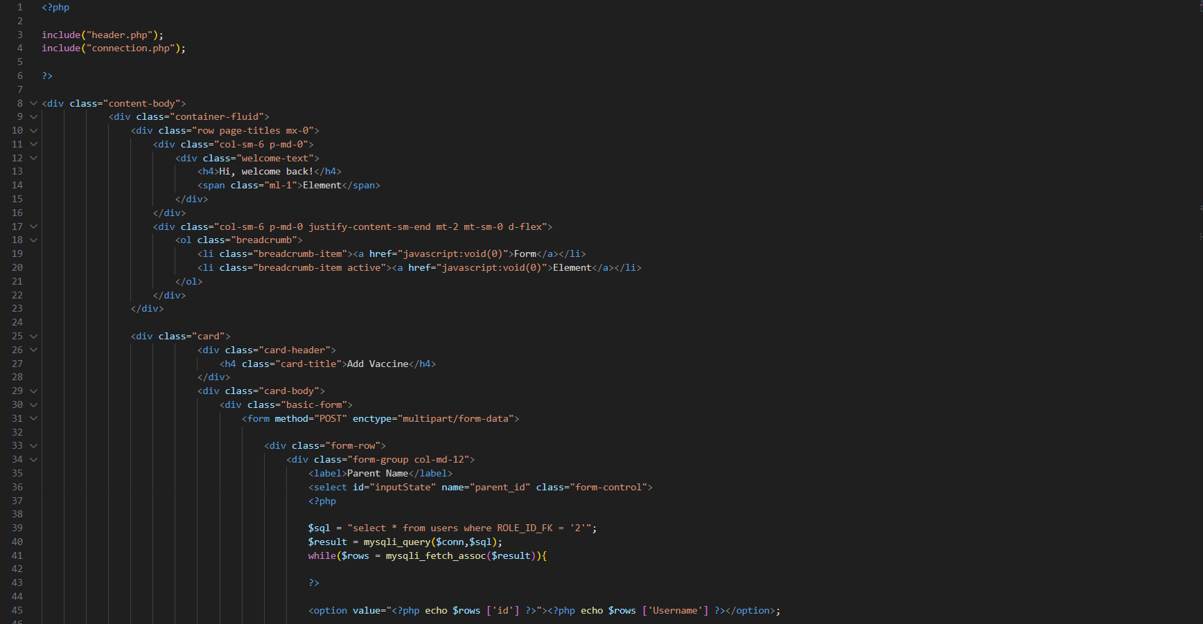

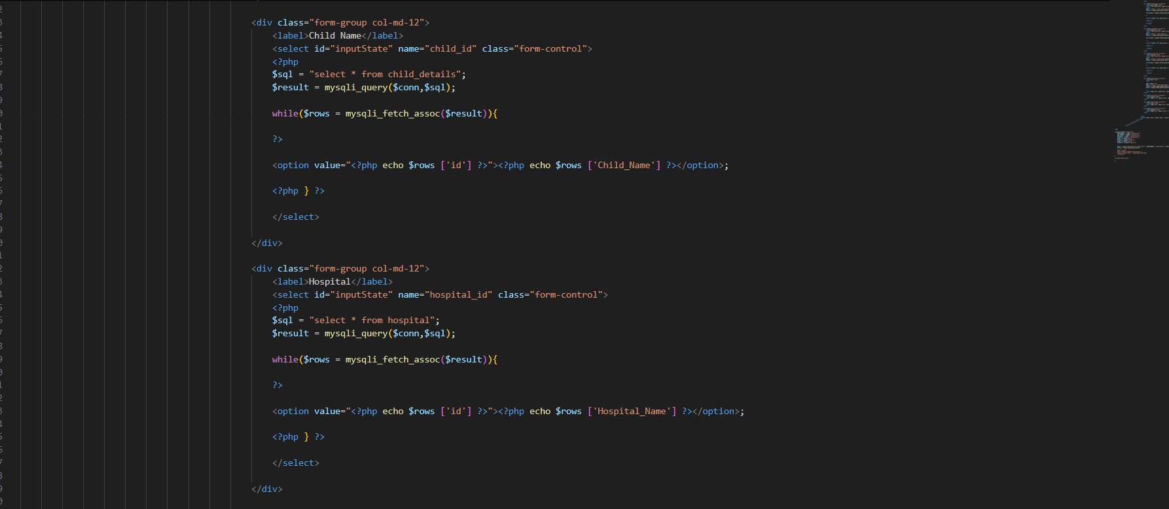

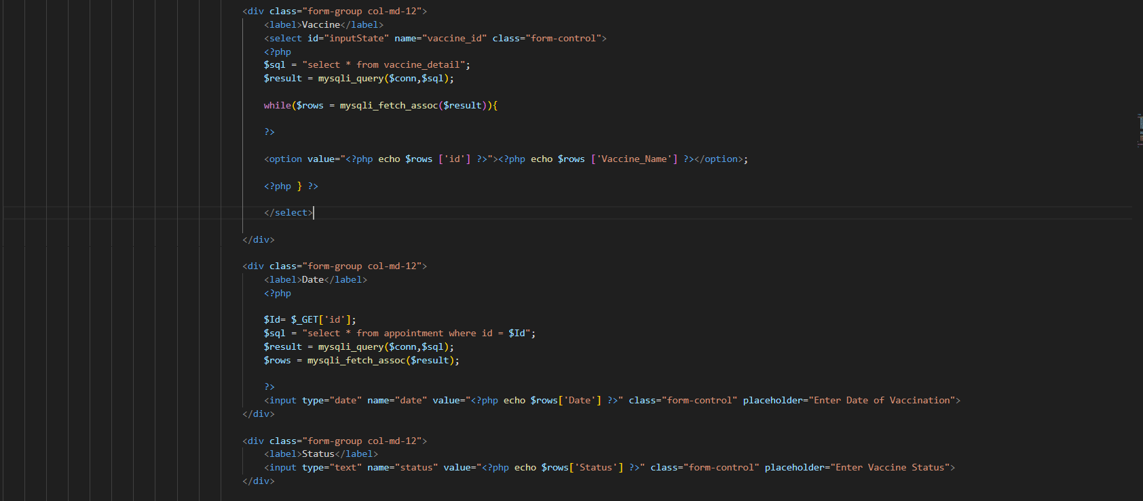

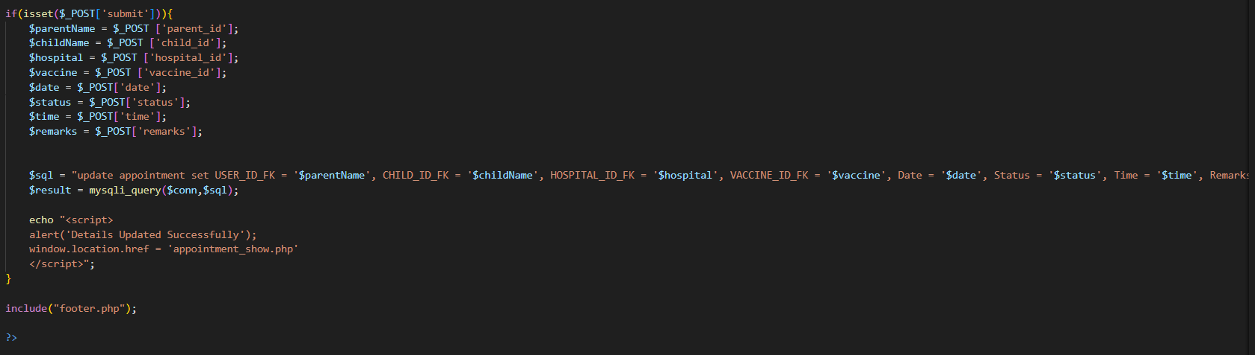

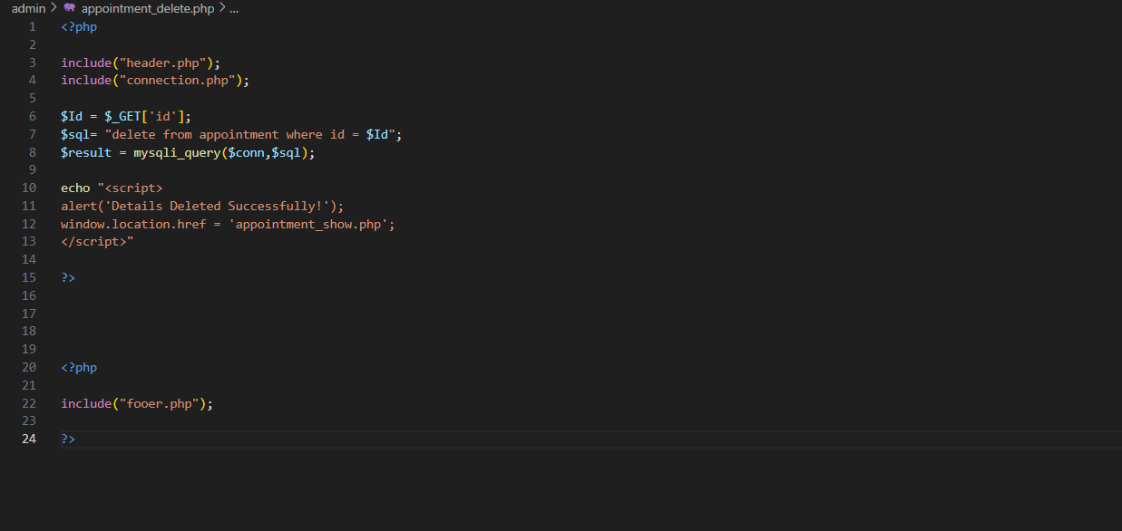

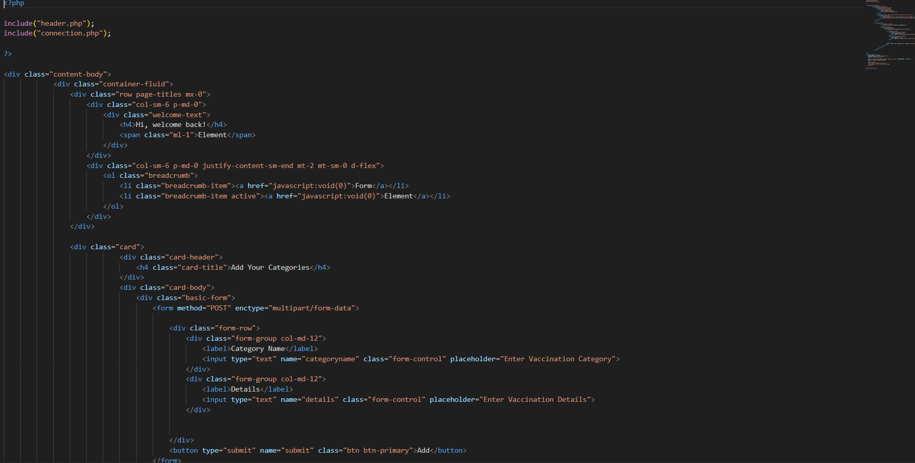

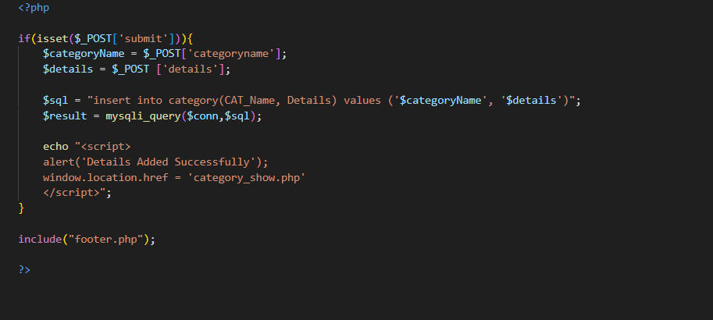

Thank you so much for reading our Developer Guide Manual of the Website.

